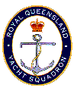

**RQYS Powerboat Cruising Group**

**Canaipa, Russell Island Barefoot Bowls, Macleay Island & NRL**

**Saturday 5 to Monday 7 October 2024**

***King’s Birthday Long Weekend***

**Cruise Captain: Mark McCamley, Seas The Day**

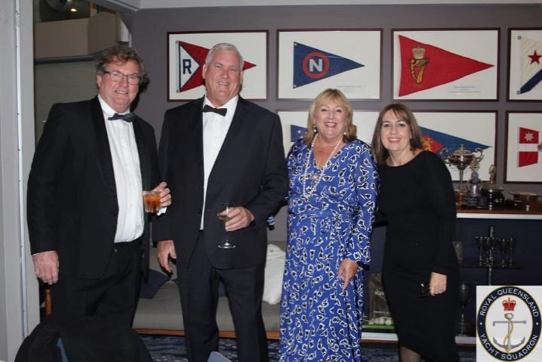

Activities include:

**Saturday:** Barefoot Bowls afternoon at Russell Island Bowls Club ($TBA).

Dinner at the bowls club (own cost). Courtesy bus from RQYS Canaipa.

All welcome even if you are not cruising, you can meet us at the Bowls club from the ferry or meet the group at RQYS Canaipa for Saturday activities. Just let Mark know if you are taking this option.

**Sunday**: MacLeay Island Bowls Club for lunch (own cost). Courtesy bus.

Macleay Island Hotel for dinner (own cost) and watch NRL Grand Final.

Info on facilities at the following links. <https://www.macleayislandhotel.com.au/>

[https://russellislandbowlsclub.com.au/#](https://russellislandbowlsclub.com.au/) <https://macleayislandbowlsclub.com.au/>

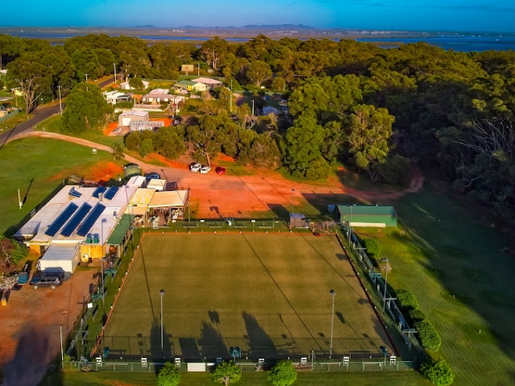

**RSVP: ASAP** … need numbers for bookings by Friday 20 September 2024

For further information or to advise your attendance please contact

Mark McCamley Mobile: 0400 778 163 or email: [marcomccamley@gmail.com](mailto:marcomccamley@gmail.com)